SCRIPTING TASK
- Create a shell script to print the HTTP error code of guvi.in & print, the success/failure message based on the error code response
#!/bin/bash
# Get the HTTP status code
status_code=$(curl -s -o /dev/null -w "%{http_code}" https://www.guvi.in)
# Print the status code
echo "HTTP Status Code: $status_code"
# Check for success or failure
if [[ $status_code -ge 200 && $status_code -lt 300 ]]; then
echo "Success: Website is reachable."
else
echo "Failure: Website returned an error."
fi
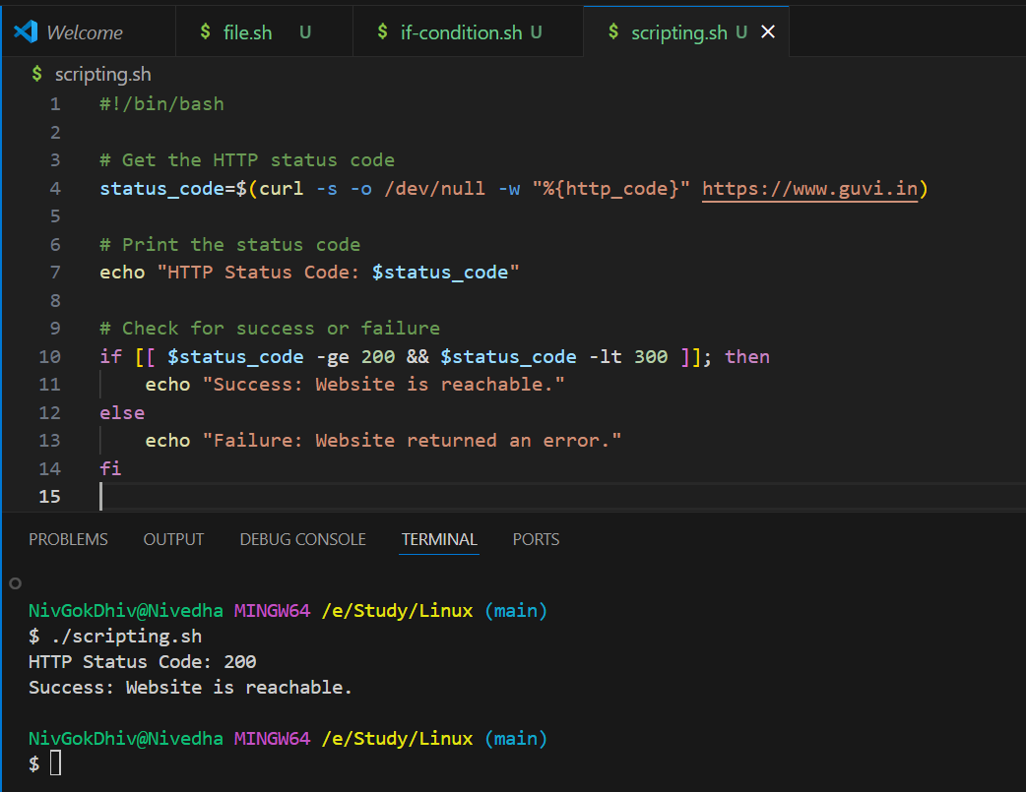
- Given a file, replace all occurrence of the word "give" with "learning" from 5th line till the end in only those lines that contain the word "welcome”
#!/bin/bash
# Input file (change this to your actual file name)
input_file="yourfile.txt"
# Use sed to do the replacement
sed -i '5,${
/welcome/ s/give/learning/g
}' "$input_file"

